Topic: The Mockingbird Metaphor
Assignment: In an introductory paragraph, two separate body paragraphs, and a conclusion paragraph, explain how the mockingbird metaphor is used. Be sure to use textual evidence to explain your points. You may bring only this sheet when writing your in-class essay. (This is a double-sided sheet)
Plan Your Essay!

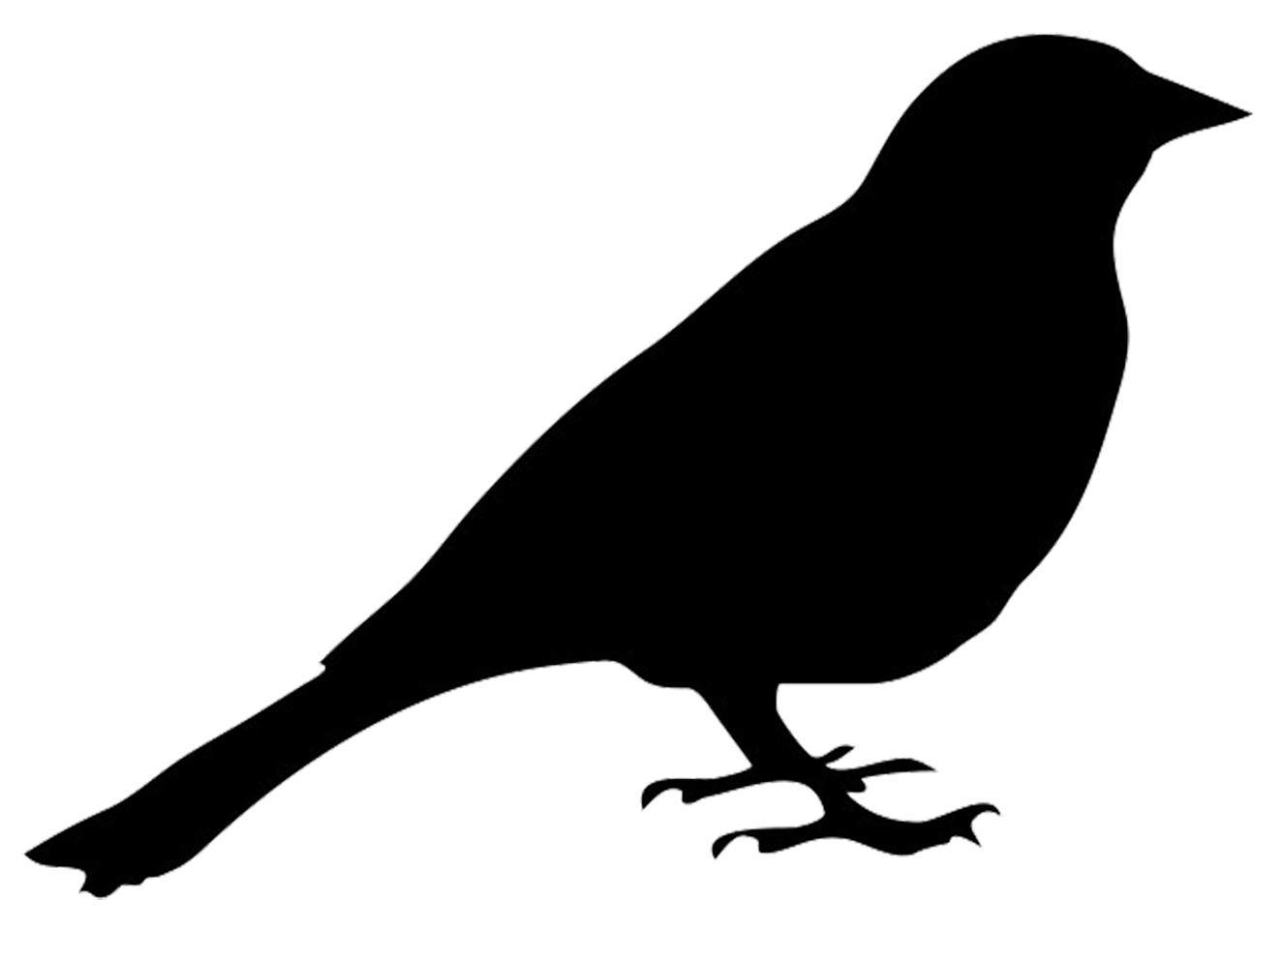

Introduction:
- Hook

- Main points you will address

- Thesis Statement (Important!)

Body Paragraph #1:
- Topic Sentence

- Main Points in your own words
  - Textual Evidence with parenthetical citation

- Closing Sentence

Body Paragraph #2:
- Topic Sentence

- Main Points in your own words
  - Textual Evidence with parenthetical citation

- Closing Sentence

Conclusion:
- State three things you want the reader to remember about the points you made (Do NOT announce. In other words, do not use phrases like “I want you to remember…”).

